Chapter 2, Problem 19.

From the circuit in Fig. 2.83, find I, the power dissipated by the resistor, and the power supplied by each source.

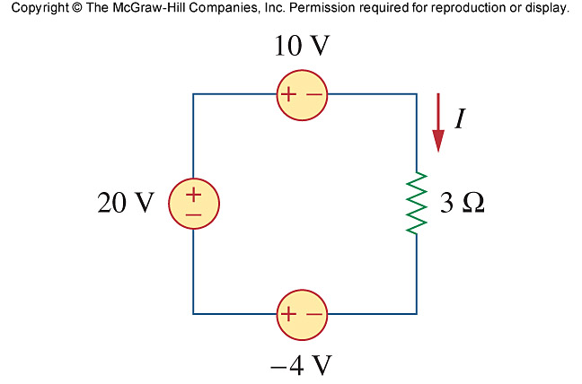
–8 V
12 V

Figure 2.83
For Prob. 2.19.

